**Charlie Team**

Tim Alvarado

Wendy Rodriguez

Grace Steranko

Nicholas Constantino

**Supplier report description**

This report shows the monthly expected and actual delivery date for each Supplier for the last 6 months. The assumptions made for this report are that each supplier makes only one delivery per month and that all supplies that they provide are delivered during that delivery. We can also assume that the winery has enough supplies left over to keep production going in the event of late deliveries. It is assumed that an on-time delivery would be measured by the actual delivery date being within 4 days of the expected delivery date.

Based on the report data we can see that supplier, Corks R Us, regularly makes their deliveries at least two weeks late, and only have delivered what would be considered on-time, once. The percentage of late deliveries for the past six months is 83% with only 17% being on time.

The data shows for supplier, Printers and Stuff, their deliveries are routinely on-time, with 100% of deliveries meeting the threshold for being considered on-time.

For the last supplier, Sampson Supplies, their deliveries are also arriving on-time 100% of the time with some actual delivery dates being ahead of the expected delivery dates.

It can be determined that Bacchus Winery should be looking at alternative supply options for their bottles and corks that are used for production.

Supplier Report Output:

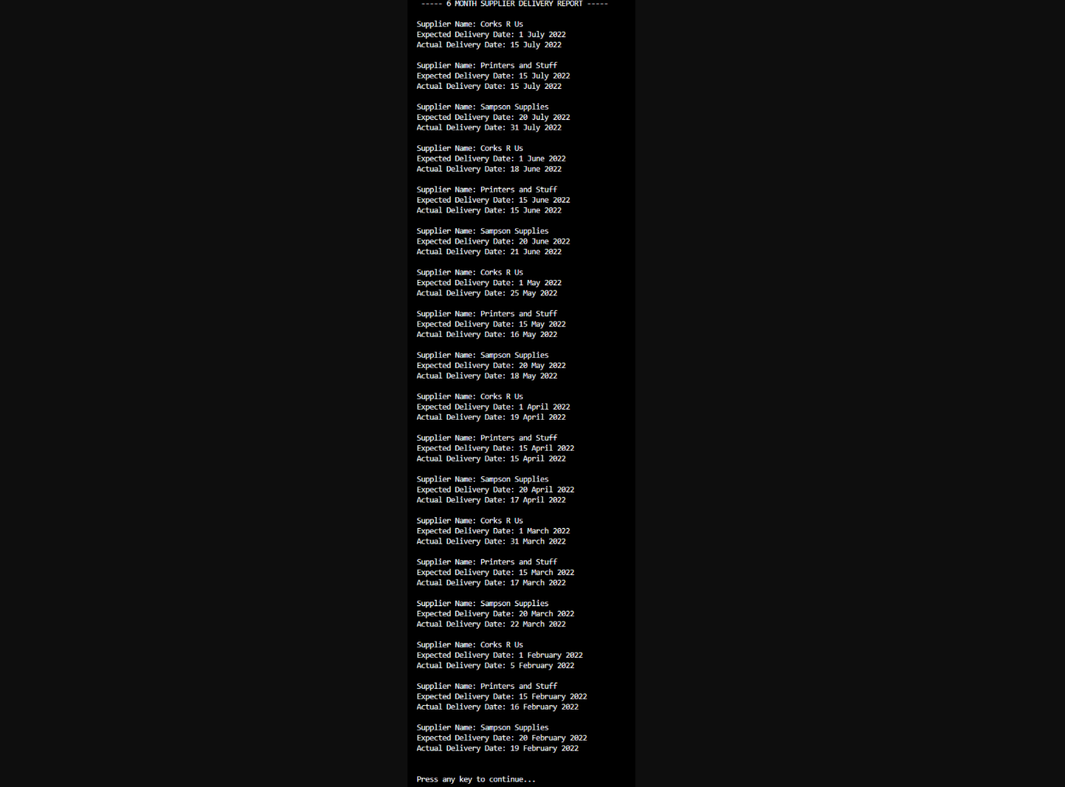

**Distributor Report description**

The reports shows that Bacchus Winery has five distributors, and each is distributing only one wine. The winery’s top selling wine is Chardonnay, with three distributors (four if including Chablis). The assumption as to why Chardonnay is the top seller is because the grapes used for wines like Merlot, and Cabernet were mostly destroyed during a wildfire and were not available for wider distribution. In the future, it is also expected that more than one wine will be carried by each distributor.

Chablis wine is imported from a sister winery in France and is only being distributed by one company now. This type of wine might have to be discontinued in the future if the cost of importing it gets to be too much for Bacchus Winery.

Distributor Report Output:

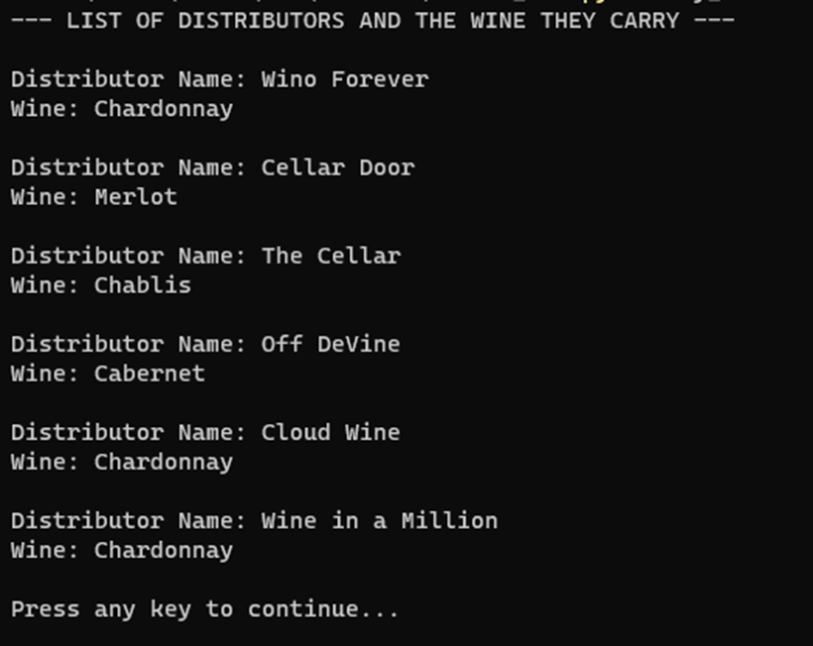

**Employee Report Description**

This report shows the logged hours for 6 of the employees of Bacchus Winery. It also shows the total number of hours worked for the last 4 quarters for each employee. We made the assumption that each employee that we chose had worked during every quarter and did not take any extended vacations during those periods of time. We also assumed that the company had an established baseline for what constitutes as an employee working a “full” hour, therefore making it feasible to put them all in the same table.

Our report shows that

Janet Collins worked 1650 hours in total over the last 4 quarters.

Roz Murphy worked 1725 hours over the last 4 quarters.

Bob Ulrich worked 1665 hours over the last 4 quarters.

Henry Doyle worked 1710 hours over the last 4 quarters.

Maria Costanza worked 1720 hours over the last 4 quarters.

Stan Bucchus worked 1837 hours over the last 4 quarters.

Our report shows that the main players of the company have all worked very comparable hours which is integral for running a sustainable business.

Employee Report Output:

